  

DESIGN AND DEVELOPMENT OF MICROSTRIP PATCH ANTENNA WITH NANOFERRITE MATERIAL

### A MINOR PROJECT-I REPORT

**Submitted by**

|  |  |
| --- | --- |
|  |  |
| **A.MONISHA** | **927621BEC129** |
|  |  |
|  |  |

## BACHELOR OF ENGINEERING

in

## DEPARTMENTOF ELECTRONICS AND COMMUNICATION ENGINEERING

**M.KUMARASAMY COLLEGE OF ENGINEERING**

(Autonomous)

## KARUR – 639 113

**DECEMBER 2022**

M.KUMARASAMY COLLEGE OF ENGINEERING, KARUR

## BONAFIDE CERTIFICATE

Certified that this project report “DESIGN AND DEVELOPMENT OF MICROSTRIP PATCH ANTENNA WITH NANOFERRITE MATERIAL” is the bonafide work of " M.MUTHULAKSHMI(927621BEC130), A.MONISHA(927621BEC129), G.NANDHINI

(927621BEC131), S.NAVANEETHA(927621BEC134)”who carried out project work under my supervision in the academic year 2022-2023.

|  |  |
| --- | --- |
| **SIGNATURE** | **SIGNATURE** |
| Dr.S.PALANIVELRAJAN, M.E., Ph.D.,  **HEAD OF THE DEPARTMENT,** | Dr.R.RAJESH KANNA, M.Tech., Ph.D.,  **SUPERVISOR,** |
| Professor, | Assistant Professor, |
| Department of Electronics and | Department of Electronics and |
| Communication Engineering, | Communication Engineering, |
| M.Kumarasamy College of Engineering, | M.Kumarasamy College of Engineering, |
| Thalavapalayam, Karur-639113. | Thalavapalayam, Karur-639113. |

This Minor project-I report has been submitted for the **18ECP103L – Minor Project-I**

Review held at M. Kumarasamy College of Engineering, Karur on _

### PROJECT COORDINATOR

**Vision of the Institution**

To emerge as a leader among the top institutions in the field of technical education

### Mission of the Institution

**M1:** Produce smart technocrats with empirical knowledge who can surmount the global challenges

**M2:** Create a diverse, fully engaged, learner-centric campus environment to provide quality education to the students

**M3:** Maintain mutually beneficial partnerships with our alumni, industry, and Professional associations

### Vision of the Department

To empower the Electronics and Communication Engineering students with emerging technologies, professionalism, innovative research, and social responsibility.

### Mission of the Department

**M1:** Attain the academic excellence through innovative teaching learning process, research areas & laboratories and Consultancy projects.

**M2:** Inculcate the students in problem solving and lifelong learning ability.

**M3:** Provide entrepreneurial skills and leadership qualities.

**M4:** Render the technical knowledge and skills of faculty members.

### Program Educational Objectives (PEOs):

**PEO1: Core Competence:** Graduates will have a successful career in academia or industry associated with Electronics and Communication Engineering.

**PEO2: Professionalism:** Graduates will provide feasible solutions for the challenging problems through comprehensive research and innovation in the allied areas of Electronics and Communication Engineering.

**PEO3: Lifelong Learning:** Graduates will contribute to the social needs through lifelong learning, practicing professional ethics and leadership quality

### Program Outcomes (POs):

**PO 1: Engineering knowledge:** Apply the knowledge of mathematics, science, engineering fundamentals, and an engineering specialization to the solution of complex engineering problems.

**PO 2: Problem analysis:** Identify, formulate, review research literature, and analyze complex engineering problems reaching substantiated conclusions using first principles of mathematics, natural sciences, and engineering sciences.

**PO 3: Design/development of solutions:** Design solutions for complex engineering problems and design system components or processes that meet the specified needs with appropriate consideration for the public health and safety, and the cultural, societal, and environmental considerations.

**PO 4: Conduct investigations of complex problems:** Use research-based knowledge and research methods including design of experiments, analysis and interpretation of data, and synthesis of the information to provide valid conclusions.

**PO 5: Modern tool usage:** Create, select, and apply appropriate techniques, resources, and modern engineering and IT tools including prediction and modeling to complex engineering activities with an understanding of the limitations.

**PO 6: The engineer and society:** Apply reasoning informed by the contextual knowledge to assess societal, health, safety, legal and cultural issues, and the consequent responsibilities relevant to the professional engineering practice.

**PO 7: Environment and sustainability:** Understand the impact of the professional engineering solutions in societal and environmental contexts, and demonstrate the knowledge of, and need for sustainable development.

**PO 8: Ethics:** Apply ethical principles and commit to professional ethics and responsibilities and norms of the engineering practice.

**PO 9: Individual and teamwork:** Function effectively as an individual, and as a member or leader in diverse teams, and in multidisciplinary settings.

**PO 10: Communication:** Communicate effectively on complex engineering activities with the engineering community and with society at large, such as, being able to comprehend and write effective reports and design documentation, make effective presentations, and give and receive clear instructions.

**PO 11: Project management and finance:** Demonstrate knowledge and understanding of the engineering and management principles and apply these to one’s own work, as a member and leader in a team, to manage projects and in multidisciplinary environments.

**PO 12: Life-long learning:** Recognize the need for and have the preparation and ability to engage in independent and life-long learning in the broadest context of technological change.

### Program Specific Outcomes (PSOs):

**PSO1:** Applying knowledge in various areas, like Electronics, Communications, Signal processing, VLSI, Embedded systems etc., in the design and implementation of Engineering application.

**PSO2:** Able to solve complex problems in Electronics and Communication Engineering with analytical and managerial skills either independently or in team using latest hardware and software tools to fulfil the industrial expectations **Program Specific Outcomes**

**PSO1:** Applying knowledge in various areas, like Electronics, Communications, Signal processing, VLSI, Embedded systems etc., in the design and implementation of Engineering application.

**PSO2:** Able to solve complex problems in Electronics and Communication Engineering with analytical and managerial skills either independently or in team using latest hardware and software tools to fulfil the industrial expectations.

|  |  |
| --- | --- |
| **Abstract** | Matching with PO,PSO |
| keywords | PO1, PO3, PSO1,PSO2 |

## ABSTRACT

Microstrip patch antenna is mostly used in modern communication devices over conventional antennas. In this study, novel ﬂexible substrates based on CuDy0.15Fe1.85O4 nanoferrite having an average grain size of 36 nm were prepared using the sonochemical synthesis technique for microstrip patch antenna applications. The synthesized ferrites materials were characterized with X-ray diffractions, scanning electron microscope, dielectric study and vibrating sample magnetometer. Dysprosium doped copper nano ferrite material used as a dielectric material with its dielectric constant = 4.87 which was observed from dielectric study for the prepared material. The rectangular microstrip patch antenna is designed using HFSS software. The designed antenna has a resonating frequency of 2.4 GHz which is applicable to wireless local area network (WLAN).

The studies were taken on the basis of the simulated design in HFSS simulation software. Using ferrite material, the patch size reduced to 37% compare to antenna printed on dielectric substrate. Comparing the values of return loss radiation power, gain, quality factor and VSWR for antenna on ferrite substrate which is better than the antenna on dielectric substrate but the bandwidth and directivity of antenna was much affected negatively. For this work we have synthesized the polycrystalline copper ferrite by the solid-state reaction technique (SSRT) and characterized their electric and magnetic properties.

**KEYWORDS**: Nanoferrites, HFSS, Microstrip patch antenna, Dielectric constant

### TABLE OF CONTENTS

|  |  |  |
| --- | --- | --- |
| **CHAPTER NO.** | **CONTENTS** | **PAGE No.** |
|  | **INSTITUTION VISION AND MISSION** | 3 |
|  | **DEPARTMENT VISION AND MISSION** | 4 |
|  | **DEPARTMENT PEO, PO AND PSO** | 5 |
|  | **ABSTRACT** | 7 |
|  | **LIST OF FIGURES** | 9 |
|  | **LIST OF ABBREVIATIONS** | 10 |
| **1** | **INTRODUCTION** | 11 |
| **2** | **LITERATURE REVIEW** | 12 |
| **3** | **METHODOLOGY** | 15 |
| **4** | **TOOLS USED** | 15 |
| **5** | **EXPERIMENTAL TECHNIQUES** | 17 |
| **6** | **MATERIALS AND METHODS** | 18 |
| **7** | **RESULTS AND DISCUSSION** | 19 |
| **8** | **CONCLUSION** | 22 |
|  | **REFERENCE** | 23 |

**LIST OF FIGURE**

|  |  |  |
| --- | --- | --- |
| FIGURE NO. | TITLE | PAGE NO |
| 4.1 | HFSS LOGO | 15 |
| 7.1 | S Parameter of Dy doped copper nanoferrite material | 19 |
| 7.2 | Terminal VSWR of Dy doped copper nanoferrite | 20 |
| 7.3 | Radiation Gain pattern of Dy doped copper nanoferrite material | 21 |
| 7.4 | Polarisation Gain of Dy doped copper nanoferrite material | 21 |
|  | **LIST OF TABLE** |  |
| TABLE NO. | TITLE | PAGE NO |
| 5.1 | Design Parameters of microstrip patch antenna | 17 |

**LIST OF ABBREVIATIONS**

|  |  |  |
| --- | --- | --- |
| HFSS | - | High Frequency Simulation Software |
| VSWR | - | Voltage Standing Wave Ratio |
| GHz | - | Gigahertz |

# INTRODUCTION

Antennas are key components of any wireless system. An antenna is a device that transmits and/or receives electromagnetic waves. Most antennas are resonant devices, which operate efficiently over a relatively narrow frequency band. An antenna must be tuned to the same frequency band that the radio system to which it is connected operates in, otherwise reception and/or transmission [1].

Over the past one decade, there is a rapid growth in development of wireless communication applications and the performance of all such wireless systems depends on the design of antennas. Antennas play a major role in such medical monitoring systems since they provide communication between sensor and external equipment. Due to many advantages microstrip antennas are preferred for majority of biomedical applications and it has become a rapidly growing area of research. Their potential applications are limitless, because of their light weight, compact size, and ease of manufacturing. However, the design of such antennas is quite challenging in terms of antenna size, impedance matching, low power requirements, and biocompatibility with the body’s physiology [2].

The modern communication systems in civil sector, satellite communication, radar applications etc,.. require size reduction of antennas. Such communication system requires antennas with low weight, low cost, low profile, easy integration into microwave ICs without affecting their antenna parameters. Therefore size reduction or miniaturization has become a very important matter nowadays in the development of patch antennas. The necessary and sufficient characteristics of antennas are small physical size, wide bandwidth and high radiation efficiency [2].

# LITERATURE REVIEW

A microstrip rectangular patch antenna fabricated on LiTiMg ferrite substrate is presented which has also been compared with same structure of antenna on dielectric.For this work we have synthesized the polycrystalline LiTiMg ferrite by the solid state reaction technique (SSRT) and characterized their electric and magnetic properties.The proposed materials offerstunable dielectric and magnetic properties with soft magnetic behaviours and easy to use where arbitrarily electromagnetic values are required. Moreover, these materials also can be played significant role in flexible microwave field as low cost flexible substrates for compact flexible antennas, metamaterials, absorbers, and sensors applications etc. The lower dielectric losses and magnetic losses for all compositions of ferrite material were useful for miniaturization of antenna. The patches of silver material were printed on fabricated substrates by using screen printing technique. The objective is to achieve matching impedances, low magnetic and dielectric losses (tan δμ and tan δε , respectively), and a relatively large miniaturization factor to reduce antenna size [1].

The ferrites with chemical formulae MgFe2O4, Mg0.6Cd0.4Fe2O4 and Mg0.2Cd0.8Fe2O4 specified with Ferrite S1, S2 and S3 were prepared by the oxalate co-precipitation method using AR grade sulphates under microwave sintering technique. The single phase cubic spinel structure formation of all the ferrites was confirmed by XRD and FTIR techniques. The dielectric parameters such as permittivity (εr), dielectric loss tangent (tanδe), permeability (µr) and magnetic loss tangent (tanδm) were determined from parameters S11 and S21 by using material measurement software with VNA. The synthesized ferrites S1, S2 and S3 with determined dielectric parameters were used as substrate to design rectangular microstrip patch antenna by simulation using Ansoft Designer SV 2.2. The designed antennas were fabricated by using screen printing technique. The return loss (RL), 10dB % bandwidth and VSWR of these fabricated antennas were measured on vector network analyzer. The simulated and measured values of resonating frequency, return loss (RL), 10dB % bandwidth and VSWR were nearly matched with each other [2].

The magneto-dielectric Mg-Nd-Cd spinel ferrites with chemical formula MgxCd1- xNd0.03Fe1.97O4 (x = 0, 0.2, 0.4, 0.6, 0.8 and 1.0) was synthesized by oxalate co-precipitation method under microwave sintering. The electromagnetic input parameters of these ferrites required for design of antennas were investigated in the X-band range. The miniaturization factor found to be highest for composition x = 0.4. The lower dielectric losses and magnetic losses for all compositions of ferrite material were useful for miniaturization of antenna. The patches of silver material were printed on fabricated substrates by using screen printing technique. The performance of return loss, % bandwidth and VSWR indicates that Mg-Nd-Cd ferrite substrates with compositions x = 0.2, 0.8 will have a strength for application as substrates of MPA in X- band microwave communication [3].

In this study, novel flexible microwave substrates based on CoxZn(0.90-x)Al0.10Fe2O4 nano-powder having an average grain size of 20 nme26 nm were prepared using the solegel synthesis technique for microstrip patch antenna applications. At first there are three different molecular composition were chosen having the chemical formula of CoxZn(0.90- x)Al0.10Fe2O4 and specified as Co20, Co40 and Co60 for x ¼ 20%, x ¼ 40% and x ¼ 60% respectively. Then the synthesized ferrites materials were characterized with XRD, FESEM,and VSM analysis, and single-phase spinel with high crystallinity were revealed. Besides,the dielectric and magnetic properties of the proposed CoeZn ferrites samples were investigated for the affirmations of microwave applications. The values of dielectric constant εr and loss tangent (Td) are determined using dielectric assessment kit, and the obtained values are ranges from 3.5 to 4.5 for εr and 0.002 to 0.006 for Td for Co20, Co40, and Co60 respectively. Also, the magnetic permeability mr and magnetic loss tangent (Tdm) values are determined to form the predetermined scattering parameters S11 and S21 obtained from rectangular substrate pellets and the obtained values of mr and Tdm are ranges from 0.90 to 1.00 and 0.003 to 0.007 respectively [4].

The effects of Cd2+ ions on the microstructure, magnetic properties, and dielectric properties of Bi2O3-added MgFe2O4 ferrites (CdxMg1-xFe2O4, x=0.00, 0.15, 0.30 and 0.45) are obtained by adopting the solid-state reaction method at a low temperature (910 °C). The objective is to achieve matching impedances, low magnetic and dielectric losses (tan δμ and tan δε , respectively), and a relatively large miniaturization factor to reduce antenna size. Experimental results indicate that the cations occupying the tetrahedral (A) and octahedral (B) ion sites are redistributed, resulting in an enhanced super-exchange interaction between the two sublattices. As a result, improved magnetization, including the increase in saturation magnetization (41.74 emu/g) and decrease in coercivity (63.75Oe), is realized. The real part of permeability (μ’) also increases with increasing concentration of Cd2+ ions. When x is 0.15, matching impedances with equivalent μ’ and ε’ values are obtained over a long frequency range (1–150MHz). Moreover, the formation of a dense microstructure guarantees that lossesoccur at low orders of magnitude (tan δμ ≈ 10−2 and tan δε ≈ 10−3). Accordingly, these properties afford wide application perspectives for the proposed compounds in the high-frequency region, i.e., from high-frequency to very-high-frequency bands [5].

BaCo1.3Ti1.3Fe9.4O19 ferrite was synthesized by solid-state reaction route. Co and Ti ions were substituted for Fe cation to modify the anisotropy field of the ferrite. The effects of B2O3 and CuO sintering additives on the phase stability, sintering behavior at 900°C, microstructure development, magnetic and dielectric properties of the ferrite were investigated. The densification of the ferrite at 900°C was found to increase upon B2O3 and CuO addition. A permittivity of 19 and initial permeability of 11 was obtained in the ferrite containing 5 wt% B2O3 sintering additive. There was a nominal decrease in saturation magnetization of the ferrite with increasing sintering additive. An antenna based on the low temperature sintered ferrite substrate was designed. Antenna parameters such as resonance frequency, return loss, voltage standing wave ratio (VSWR), and bandwidth were simulated and reported [6].

# METHODOLOGY

The methodology for design and development of microstrip patch antenna depends on various techniques used to simulate different parameters of the antenna. The proposed antenna was designed using Dysporsium copper ferrite substrate. The major performance parameters such as antenna gain, bandwidth and return loss were observed [2].

# TOOLS USED

Software requirement: HFSS Software

Ansys HFSS is a 3D electromagnetic (EM) simulation software for designing and simulating high-frequency electronic products such as antennas, antenna arrays, RF or microwave components, high-speed interconnects, filters, connectors, IC packages and printed circuit boards [1].



### Fig.no.4.1 HFSS LOGO

Engineers use Ansys HFSS primarily to design and simulate high-speed, high-frequency electronics in radar systems, communication systems, satellites, ADAS, microchips,printed circuit boards, IoT products, and other digital devices and RF devices. The solver has also been used to simulate the electromagnetic behavior of objects such as automobiles .ANSYS HFSS allows system and circuit designers to simulate EM issues such as losses due to attenuation, coupling, radiation and reflection.The benefits of simulating a circuit's high frequency behavior with high accuracy on a computer reduces the final testing and verification effort of the system as well as mitigating the necessity of building costly multiple prototypes, saving both time and money in product development. HFSS captures and simulates objects in 3D, accounting for materials composition and shapes/geometries of each object. HFSS is one of several commercial tools used for antenna design, and the design of complex radio frequency electronic circuit elements including filters, transmission lines, and packaging [1].

HFSS software is little difficult to understand but once you design few basic filters or antennas, it will be easy for you to design further implementations.The HFSS integral equation (HFSS-IE) solver uses the method of moments (MoM) technique to solve for the sources or currents on the surfaces of conducting and dielectric objects in open regions. HFSS-IE is effective for radiation and scattering studies of large, mostly conducting structures [2].

# EXPERIMENTAL TECHNIQUES

The structural parameters of rectangular microstrip antenna obtained on the basis of theoretical rectangular wave guide model which is one of the finest models for the explanation of the working for this type of antenna structures. With the theoretical calculation antenna has been simulated and optimized by EM Talk Microstrip Patch Antenna and Microstrip Line calculator [6].

### Table:5.1 Design parameters of microstrip patch antenna

|  |  |
| --- | --- |
| Height | 1.6 mm |
| Dielectric constant | 4.87 |
| Dielectric loss tangent | 6.21 |
| Relative frequency | 2.4 GHz |

The design of antennas was explained in following steps. First step was to choose the operating frequency (fr) at which the microstrip patch antenna to be designed. In present investigation, the proposed microstrip patch antenna was designed at operating frequency 2.4 GHz. The second step was selection of substrate material with required values of input design parameters such as permittivity (εr), dielectric loss tangent (tanδe), to miniaturize size of antenna with increased performance**.** The ground is used in telecommunication ,a ground plane is a flat or nearly horizontal surface that serves as part of an antenna ,to reflect the radio waves from the other antenna elements. The substrate properties such as its dielectric constant of material ,loss tangent have good effect on the antenna characteristics. The Patch antenna is mainly practical of microwave frequencies. It is widely used in portable wireless devices because of the case of fabricating it on printed circuit board [7].

# MATERIALS AND METHODS

Antennas can be designed with different substrates to achieve the desired performance. The substrates are chosen taking into consideration the ease of fabrication and its biocompatibility when compared to other semiconductors. The selection of height and dielectric constant of the substrate helps in achieving high directivity and better radiation efficiency. One among such antennas are nanoferrite based patched microstrip antennas which are used for applications at 2.4GHz. For performance, predictions and simplified analysis, a rectangular shaped microstrip patch antenna operating at 2.4GHz is proposed. The dimensions of the microstrip patch antenna were designed using the approximation equation below [1].

* 1. The Patch Width, W

W = c/2f0√(𝜀𝑟+1)/2 2.Effective Dielectric Constant, 𝜀reff

𝜀𝑒𝑓𝑓 =𝜀𝑟+1/2+𝜀𝑟−1/2[1 + 12 ℎ/𝑤]−1/2

1. Effective Length, Leff

Leff =𝑐/2𝑓𝑜√𝜀𝑒𝑓𝑓

The patch of the antenna is electrically longer than the physical dimension due to fringing factor. This factor is subtracted from the effective length to give the actual length of the patch which is given by:

∆𝐿 = 0.412ℎ(𝜀𝑒𝑓𝑓+0.3)(𝑊/ℎ+0.264)/(𝜀𝑒𝑓𝑓−0.258)(𝑊/ℎ**+**0.8)

1. Ground plane dimensions

Wg = 6h + W Lg = 6h + L

Where Wg is the width of the ground plane in mm, Lg is the length of the ground plane in mm.In this project, inset fed antenna structure as a rectangular microstrip patch antenna is used. It shows proposed antenna structure and the names of its dimensions.

# RESULTS AND DISCUSSION

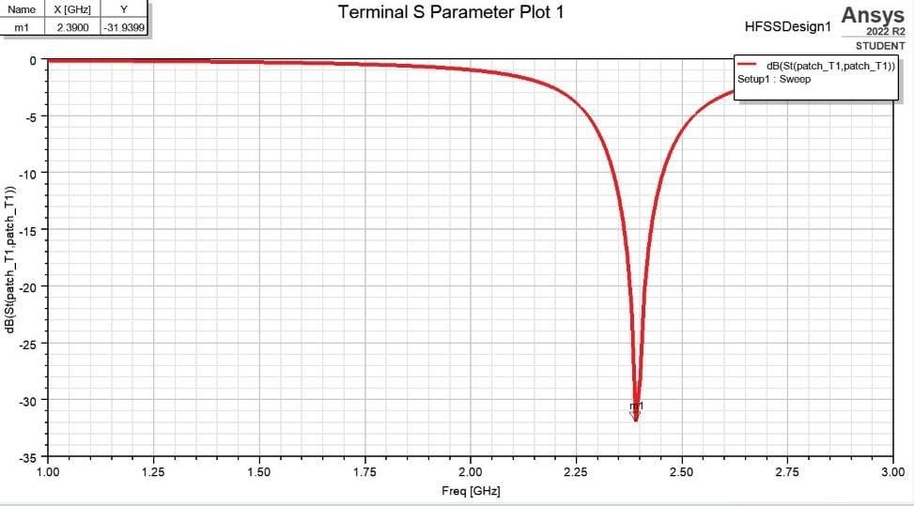

### Fig.no.7.1 S Parameter of Dy doped copper nanoferrite

Fig no.7.1 shows that the S parameter of Dy doped copper nanoferrite which indicates that the parameter plot at exactly at 2.4GHz frequency. S parameter indicates the return loss value from 0 to 60 dB [3].

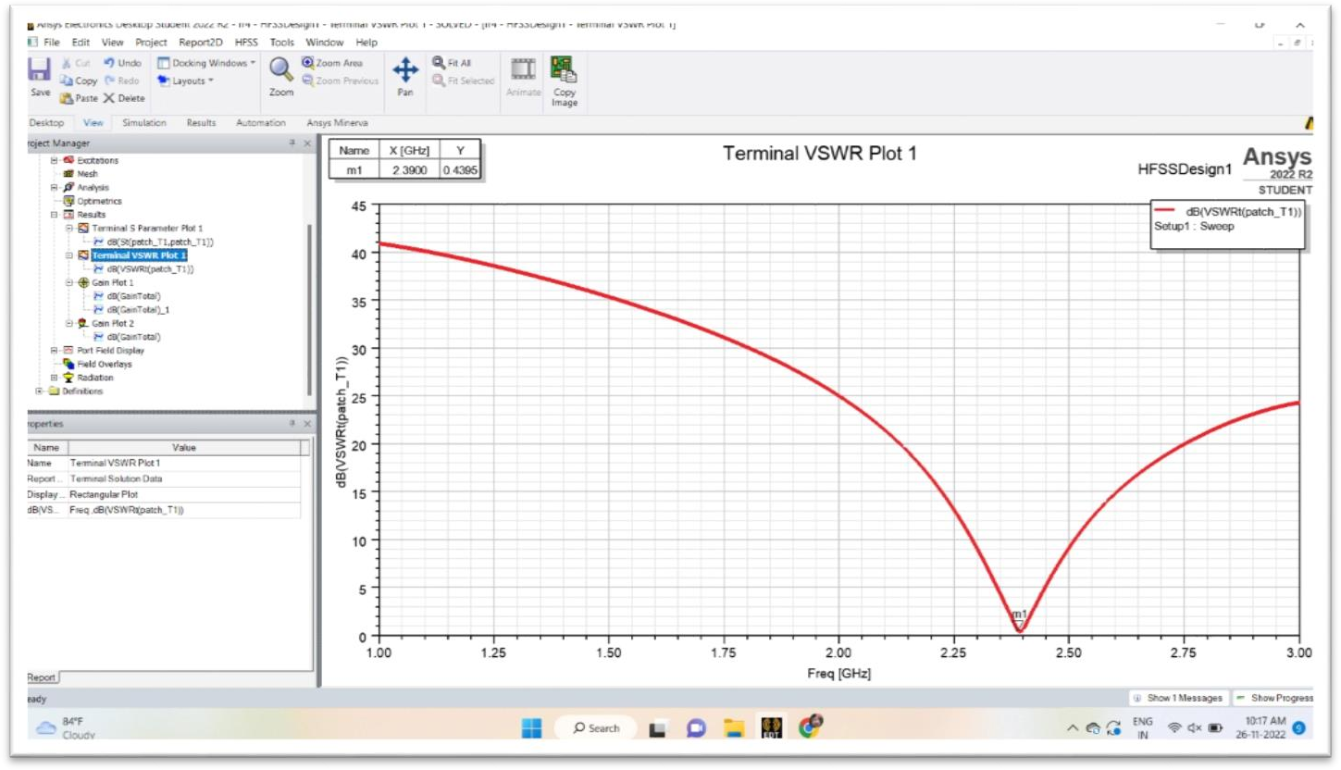

### Fig.no.7.2 Terminal VSWR of Dy doped copper nanoferrite

**VSWR** is a measure of how efficiency ratio frequency power transmitted from a power source through a transmission line into a load [3].

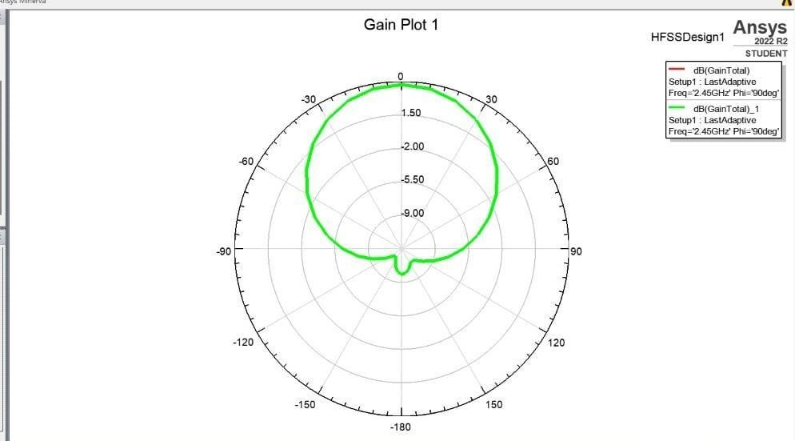

### Fig.no:7.3 Radiation Gain pattern of Dy doped copper nanoferrite

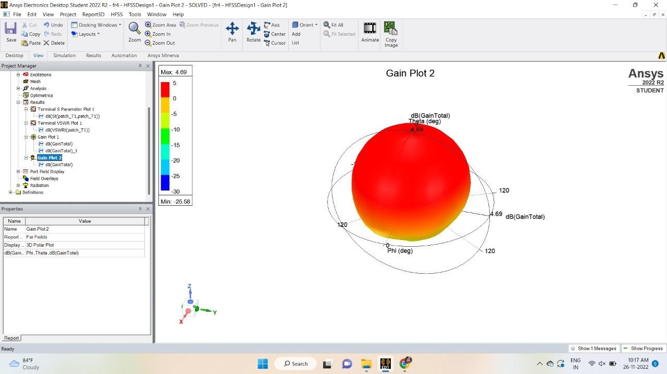

**Fig.no.7.4 Polarisation Gain of Dy doped copper nanoferrite**

Gain:The radiation pattern of an antenna gives us information about its receiving and transmitting properties in different directions. The radiation pattern of an antenna one of its basic property [4].

# CONCLUSION

From the above results we get antenna which is operating at 2.4 GHz frequency. In world 2.4 GHz frequency applications are connect devices for low bandwidth activities like browsing the internet model aircrafts, model boats and toys and many radio controlled drones. On the 2.4 GHz band, you can connect upto devices depending upon the bandwidth usuage of the device. If the Bluetooth technology uses the 2.4 GHz ISM spectrum band. Many of cordless telephones and body monitors are used in USA and Canada use the 2.4 GHz frequency.

# REFERENCE

* 1. M.M. Syazwan ,A.N. Hapishah , M.N. Hamidon , I. Ismail , I.H. Hasan,Design and development of Ni0.75Zn0.25Fe2O4/MWCNT microstrip patch antenna (MPA) for ISM band spectrum applications,The Journal of Electronic Polymers and Electronic Molecular
  2. Md Atiqur Rahman, Mohammad Tariqul Islam , Mandeep Jit Singh, Ismail Hossain , Hatem Rmili,MdSamsuzzaman,Magnetic, dielectric and structural properties of CoxZn(0.90-x)Al0.10Fe2O4 synthesized by solegel method with application as flexible microwave substrates for microstrip patch antenna,Journel of Materials Research and Technology, 20, 2022.
  3. Naveen Kumar Saxena Nitendar Kumar P.K.S.Pourush, Radiation Characteristics of Microstrip Rectangular Patch Antenna Fabricated on LiTiMg Ferrite Substrate, International Journal of Electronics and Communications, 96 (2018), 246-251.
  4. Vinaykumar,J. Bera, Characterizations of low-temperature sintered BaCo1.3Ti1.3Fe9.4O19 M-type ferrite for high-frequency antenna application,Journal of Magnetism and Magnetic Material, 451,2018,614-619
  5. Shikha Sukhija, Rakesh K., Sarin A., A U-Shaped Meandered Slot Antenna for Biomedical Applications, Progress In Electromagnetics Research M 2017;62: 65-77
  6. Renato Ci, Emanuela M., Orlandino T., Wideband and UWB Antennas for Wireless Applications: A Comprehensive Review, Hindawi, International Journal of Antennas and Propagation Volume 2017, Article ID 2390808
  7. Motevasselian A. Whittow W.G., Patch size reduction of rectangular microstrip antennas by means of a cuboid ridge, IET Microw. Antennas Propag., 2015; 9 (15): 1727-1732.
  8. Wakrim L.; Ibnyaich, S.; Hassani M. M., The study of the ground plane effect on a Multiband PIFA Antenna by using Genetic Algorithm and Particle Swarm Optimization.

J. Microw. Optoelectron. Electromagn. Appl., São Caetano do Sul, 2016; 15(4): 293- 308.

* 1. Borah K., Bhattacharyya N. S. Magneto-dielectric composite with ferrite inclusions as substrates for microstrip patch antennas at microwave frequencies. Composites: Part B 2012;43: 1309-14.
  2. J.L. Mattei, E. L. Guen, A. Chevalier, A. C. Tarot, Experimental determination of magnetocrystalline anisotropy constants and saturation magnetostriction constants of NiZn and NiZnCo ferrites intended to be used for antennas miniaturization, J. Magn. Mater. 2015; 374:762–768.





